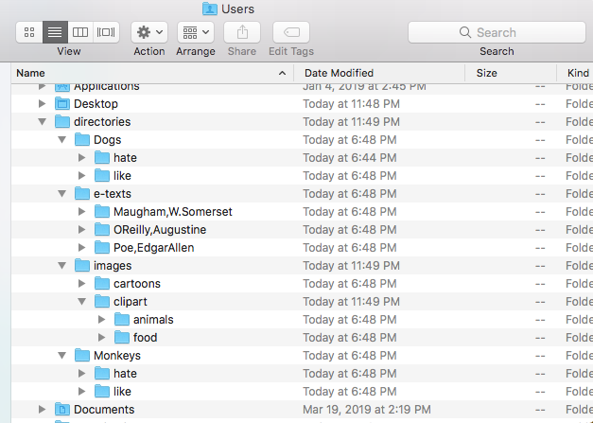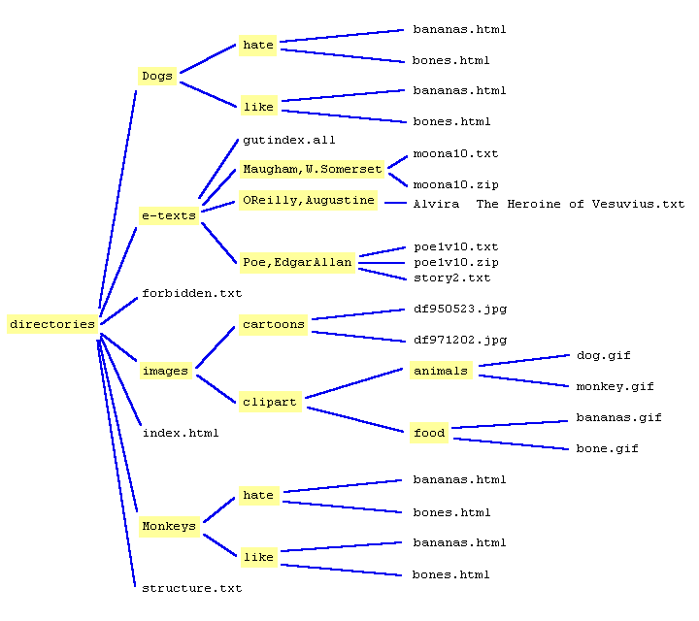  
Use the image attached as reference:

1. Build out the file paths in the image. Your root directory (folder) will be the highlighted word \*\*directories. Every highlighted word is a new directory(folder) and the non-highlighted words are plain old files.\*\*

2. If I start in my root directory (in this case it is called directories). How would I navigate to the directory called food?

cd images/clipart/food

3. From food, how would I navigate to Poe, Edgar Allen? cd ../clipart/images/directories/e-texts/”Poe,EdgarAllen

4. How would I be able to tell the contents of Poe, Edgar Allen? *ls-l* prompt can be used to tell the entire contents of the directory.

5. Navigate to images, and use the command that will tell you the exact path of where you are. *cd directories/images* to navigate to the images directory. Then use *pwd* prompt to tell the exact path.

6. While in images, create a folder called photographs. Use *mkdir photographs*

7. Navigate to your new directory, and create a new file called sunrise. Oh, and make it a .jpg file. (Windows get a freebie here). To make a new file in the photographs folder need to use *touch sunrise.jpg.*

8. Now move that file back one directory. *mv sunrise.jpg ../*

9. Change directories to the like folder under monkeys. Open this folder in sublime. cd../Monkeys/like to open this folder in Sublime; *ln -s '/Applications/Sublime Text.app/Contents/SharedSupport/bin/subl' /usr/local/bin/subl* then type *subl.* This will open the current folder in Sublime. (source Stack Overflow)

10. Bonus! Remove the bananas.html file from the like folder. *rm bananas.html*

1.

total 0

drwxr-xr-x 4 Shelliebean staff 128 Jun 11 18:48 Dogs

drwxr-xr-x 4 Shelliebean staff 128 Jun 11 18:48 Monkeys

drwxr-xr-x 5 Shelliebean staff 160 Jun 11 18:48 e-texts

drwxr-xr-x 4 Shelliebean staff 128 Jun 11 18:48 images

directories/Dogs:

total 0

drwxr-xr-x 2 Shelliebean staff 64 Jun 11 18:44 hate

drwxr-xr-x 2 Shelliebean staff 64 Jun 11 18:48 like

directories/Dogs/hate:

directories/Dogs/like:

directories/Monkeys:

total 0

drwxr-xr-x 2 Shelliebean staff 64 Jun 11 18:48 hate

drwxr-xr-x 2 Shelliebean staff 64 Jun 11 18:48 like

directories/Monkeys/hate:

directories/Monkeys/like:

directories/e-texts:

total 0

drwxr-xr-x 2 Shelliebean staff 64 Jun 11 18:48 Maugham,W.Somerset

drwxr-xr-x 2 Shelliebean staff 64 Jun 11 18:48 OReilly,Augustine

drwxr-xr-x 2 Shelliebean staff 64 Jun 11 18:48 Poe,EdgarAllen

directories/e-texts/Maugham,W.Somerset:

directories/e-texts/OReilly,Augustine:

directories/e-texts/Poe,EdgarAllen:

directories/images:

total 0

drwxr-xr-x 2 Shelliebean staff 64 Jun 11 18:48 cartoons

drwxr-xr-x 4 Shelliebean staff 128 Jun 11 18:48 clipart

directories/images/cartoons:

directories/images/clipart:

total 0

drwxr-xr-x 2 Shelliebean staff 64 Jun 11 18:48 animals

drwxr-xr-x 2 Shelliebean staff 64 Jun 11 18:48 food

directories/images/clipart/animals:

directories/images/clipart/food: